*MYSQL- Join Query*

Why?

If I want to retrieve the data from multiple data then go for join query.

By using one select statement, we can retrieve the data from multiple table.

It is used to retrieve data from multiple tables. It is performed whenever you need to fetch records from two or more tables.

There are three types of [MySQL](https://www.javatpoint.com/mysql-tutorial) joins:

* MySQL INNER JOIN (or sometimes called simple join)
* MySQL LEFT OUTER JOIN (or sometimes called LEFT JOIN)
* MySQL RIGHT OUTER JOIN (or sometimes called RIGHT JOIN)

# Inner Join-

It gives you exactly matching rows called inner join.

Syntax-

SELECT columns FROM table1 INNER JOIN table2 ON table1.column = table2.column;

Example-

Table 1-

create table customers(

customerid int(10)primary key auto_increment not null, customername varchar(32), email varchar(32), phone varchar(125));

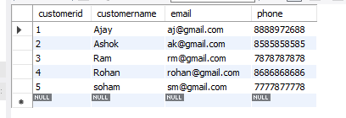

create table accounts( customerid int,

accountsid int primary key auto_increment not null,

accountstype varchar(10), balance int(50), foreign key(customerid) references customers(customerid));

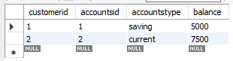

Inner Join;

Select customers.customerid,customername, email, accountsid,balance from customers INNER JOIN accounts on customers.customerid = accounts.customerid;



1. **Left outer join**-The LEFT OUTER JOIN returns all rows from the left hand table (Table 1) specified in the ON condition and only those rows from the other table where the join condition is fulfilled.

Syntax- SELECT columns FROM table1 LEFT [OUTER] JOIN table2 ON table1.column = table2.column;

Example-

select customername, email, accountsid, balance from customers left join accounts on customers.customerid = accounts.customerid;

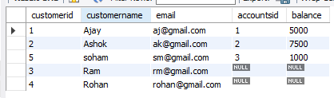

1. **Right outer join**-The MySQL Right Outer Join returns all rows from the RIGHT-hand table (Table 2) specified in the ON condition and only those rows from the other table where he join condition is fulfilled.

Syntax- SELECT columns FROM table1 RIGHT [OUTER] JOIN table2 ON table1.column = table2.column;

Example-

select customername, email, accountsid, balance from customers right join accounts on customers.customerid = accounts.customerid;

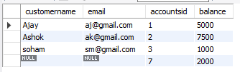

# Full outer Join-

In MySQL it is the combination of left join union right join.

select * from customers left join accounts on customers.customerid = accounts.customerid union select * from customers right join accounts on customers.customerid = accounts.customerid;

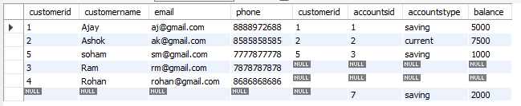

# Highest Salary Calculate Query-

Finding Nth highest salary in a table is the most common question asked in interviews.

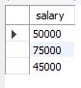

First solution- with using sub- query. 1st Highest salary

SELECT salary FROM (SELECT salary FROM student ORDER BY salary DESC LIMIT 1) AS s ORDER BY salary LIMIT 1;

2nd Highest salary

SELECT salary FROM (SELECT salary FROM student ORDER BY salary DESC LIMIT 2) AS s ORDER BY salary LIMIT 1;

Description-

In this solution, we have first sorted all salaries form Employee table in descending order, so that 2 highest salaries come at top of the result set.

After that we took just two records by using LIMIT 2.

Again we did the same thing but this time we sort the result set on ascending order, so that second highest salary comes at top.

Now we print that salary by using LIMIT.

3rd Highest salary

SELECT salary FROM (SELECT salary FROM student ORDER BY salary DESC LIMIT 3) AS s ORDER BY salary LIMIT 1;

Second solution- without using sub- query 2nd Highest Salary calculates.

SELECT salary FROM student ORDER BY salary DESC LIMIT 1,1;

Here (1, 1) -> second 1 is used for to fetch only one row or record.

First 1 is used to calculate the 2nd highest salary.